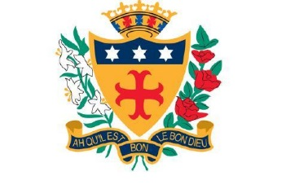

NOTRE DAME CATHOLIC COLLEGE

Great Homer Street, Liverpool L5 5AF
Tel: 0151-330 5122
Fax: 0151-207 0904

Voluntary Aided 11-19 Comprehensive College
NOR 935
Trustees: Sisters of Notre Dame
Headteacher: Mr P Duffy BA(Hons), MA, NPQH

LEARNING SUPPORT ASSISTANT (VARIOUS ROLES)

REQUIRED FOR 1ST SEPTEMBER 2021
Salary PASS Scale 3, term time only £16,557 - £16,889

Founded by the Sisters of Notre Dame in 1869, Notre Dame is a well-established coeducational Catholic College which relocated to a new state of the art premises in September 2013.

We are a Catholic school, and the teachings of our Patron, St Julie Billiart, underpins all that we do. However, we welcome students and staff from many cultures, and take positive steps to support pupils and staff with disabilities.

We are seeking to appoint a Learning Support Assistant who will support educational small groups and work with students on a one to one basis. The successful candidate will support learning and progress for students in Key Stages 3 and 4.
- To support educational needs of all students regardless of ability or SEND through delivering 1:1 or group support and interventions when required.

This post is full time, 35 hours per week during term time.
Full details and an application form can be obtained from the college website www.notredameliverpool.com

Closing date for applications is Monday 17th May at 8.00am. Interviews will take place during week commencing Monday 17th May.

Completed applications are to be emailed to recruitment@notredame.liverpool.sch.uk

Notre Dame Catholic College is committed to safeguarding and promoting children’s welfare. This post is subject to all the relevant pre-employment checks set out in Keeping Children Safe in Education, including an enhanced DBS certificate with a barred-list check.

