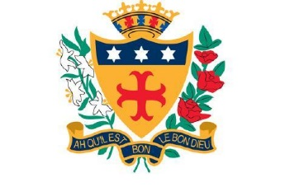

NOTRE DAME CATHOLIC COLLEGE

Great Homer Street, Liverpool L5 5AF
Tel: 0151-330 5122
Fax: 0151-207 0904

Voluntary Aided 11-19 Comprehensive College
NOR 935
Trustees: Sisters of Notre Dame
Headteacher: Mr P Duffy BA(Hons), MA, NPQH

TEACHER OF SCIENCE

REQUIRED FOR 1ST SEPTEMBER 2021
Salary Range MPS/UPS

Founded by the Sisters of Notre Dame in 1869, Notre Dame is a well-established coeducational Catholic College which relocated to a new state of the art premises in September 2013.
We are a Catholic school, and the teachings of our Patron, St Julie Billiart, underpins all that we do. However, we welcome students and staff from many cultures, and take positive steps to support pupils and staff with disabilities.
The Governors would like to invite applications for the post of Teacher of Science. We seek to recruit an enthusiastic and innovative teacher to join our successful Science Department. The post is open to both experienced teachers and NQTs, who are qualified to teach Science up to at least GCSE level.
We welcome applications from teachers whose passion for Science inspires children to learn and achieve. You will insist on the highest quality of learning and be committed to your own professional development.
You will be joining an innovative Science department. We are a supportive team and are highly ambitious for all our students.
Full details and an application form can be obtained from the college website www.notredameliverpool.com
Closing date for applications is Tuesday 2nd March at 8.00am.

Completed applications are to be emailed to recruitment@notredame.liverpool.sch.uk

Notre Dame Catholic College is committed to safeguarding and promoting the welfare of children and young people and expects all staff and volunteers to share this commitment.

